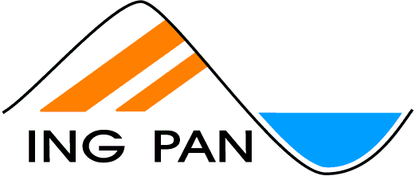 |  |  | INSTYTUT NAUK GEOLOGICZNYCH  POLSKIEJ AKADEMII NAUK  INSTITUTE OF GEOLOGICAL SCIENCES  POLISH ACADEMY OF SCIENCES
00-818 Warszawa, ul. Twarda 51/55 |  | tel. (+48 22) 697-87-00; fax. (+48 22) 620-62-23; e-mail: ingpan@twarda.pan.pl; http://www.ing.pan.pl

INSTITUTE OF GEOLOGICAL SCIENCES, POLISH ACADEMY OF SCIENCES ANNOUNCES THE COMPETITION FOR THE ADJUNCT POSITION

INSTITUTION: Institute of Geological Sciences, Polish Academy of Sciences.
LOCATION: Kraków Research Centre, Geochronology and Isotope Geochemistry Group.
POSITION: Adjunct
DISCIPLINE: Geology
Application deadline: 10.10.2021
WEBSITE: www.ing.pan.pl
KEY WORDS: Geochronology, Isotope Geochemistry, Laser Ablation, Mass Spectrometry

DESCRIPTION OF THE POSITION
The successful candidate will be working in Geochronology and Isotope Geochemistry Group conducting research in the fields of mountain building processes, geochronology, rock petrogenesis, basins evolution, rates of geological processes, reconstruction of paleoenvironment or geoarcheology. The successful applicant will join current projects or may create her/his own research program. He/She will also participate in maintaining laboratory facilities and in the forthcoming new installations of two multicollector mass spectrometers.

REQUIREMENTS
The candidates should hold a PhD degree in Earth Sciences or Inorganic Analytical Chemistry. Interest in mass spectrometry and laser ablation techniques is expected. The candidate should be fluent in using computers and basic software, should have good knowledge of English in speaking and writing, and possess good communication skills. Programming skills will be treated as an additional asset of an applicant.

Required documents

- CV
- Motivation letter

Evaluation procedure
The position is to be filled no later than in November 2021

The applications will be assessed by an independent evaluation commission, whose responsibility will be to rank the candidates according to their merits and potential. Based on this assessment, IGS PAS will sign the contract with the successful candidate.

CONTACT
Please send your application documents via email to: ingpan@twarda.pan.pl by 10th October 2021.
Competition code to put in the title of your application email: Adjunct-GIGLab.
We will contact only selected candidates.
For additional information contact Dr. hab. Robert Anczkiewicz mail: ndanczki@cyfronet.pl

